Day 9 Jacob, Leah, & Rachel: Readings: Genesis 29-36

The Vision of Jacob’s Ladder at Bethel
When Jacob traveled from Beersheba toward Haran, he had a dream [at Bethel; Genesis 28:10-19] in which he saw himself on the earth at the foot of a ladder that reached to heaven where the Lord stood above it. He beheld angels ascending and descending thereon, and Jacob realized that the covenants he made with the Lord there were the rungs on the ladder that he himself would have to climb in order to obtain the promised blessings—blessings that would entitle him to enter heaven and associate with the Lord.
Because he had met the Lord and entered into covenants with him there, Jacob considered the site so sacred that he named the place Bethel, a contraction of Beth-Elohim, which means literally ‘the house of the Lord’ [actually, ‘house of God’]. He said of it: “…this is none other but the house of God, and this is the gate of heaven.” (Gen. 28:17.)
Jacob not only passed through the gate of heaven, but by living up to every covenant he also went all the way in. Of him and his forebears Abraham and Isaac, the Lord has said: “…because they did none other things than that which they were commanded, they have entered into their exaltation, according to the promises, and sit upon thrones, and are not angels but are gods.” (D&C 132:37.)
Temples are to us all what Bethel was to Jacob. Even more, they are also the gates to heaven for all of our unendowed kindred dead. We should all do our duty in bringing our loved ones through them.
(Marion G. Romney, “Temples—The Gates to Heaven,” Ensign (Mar. 1971), 16; emphasis added.)

Teraphim at least sometimes = household gods
When Jacob left Haran in northern Aram to return to Canaan, he took his family and possessions with him. Genesis 31:19 recounts that as part of this activity, “Rachel had stolen the images [teraphim] that were her father’s.” The Hebrew noun teraphim occurs fifteen times in the Bible, but we cannot tell whether this word consistently designated the same thing over many centuries. Additionally, the etymology of the plural noun teraphim is uncertain. It is usually rendered “image(s)” or merely transliterated, as is sometimes the case in the KJV. More recent Bible translations sometimes render it as “household gods.”
Teraphim are never described in the Bible, so our limited knowledge is based on circumstantial evidence. They were generally modest-sized statues. Laban’s were small enough that “Rachel had taken the images [teraphim], and put them in the camel’s furniture [saddle], and sat upon them. And Laban searched all the tent, but found them not” (Gen 31:34). Some were apparently larger, since Michal placed a teraphim (KJV, “an image”) as a decoy under David’s bedcovers (1 Sam 19:13–16). Scholars assume that at least some of the ceramic figurines discovered in excavations throughout the Near East are teraphim.
While a few scholars have suggested that teraphim were images of ancestors or were somehow associated with property rights, most view them as images of gods that held protective powers (and possibly fertility powers) for a family. Laban referred to his teraphim as “my gods” (’elohay; Gen 31:30), and his anxious attempt to retrieve them highlights their significance to him. It is not clear why Rachel took them with her to Canaan.
Outside of Genesis, the Bible lists teraphim in conjunction with various forms of prophetically condemned religious activity. For example, King Josiah eliminated all “the wizards, and the images [teraphim], and the idols, and all the abominations” that were in Judah (2 Kgs 23:24; see also Judg 17:5; 18:14–20). Sometimes teraphim were associated with divination: “For the idols [teraphim] have spoken vanity, and the diviners have seen a lie, and have told false dreams” (Zech 10:2; see also Ezek 21:21).
Holzapfel, Pike, and Seely, Jehovah and the World of the Old Testament (2009), 61.

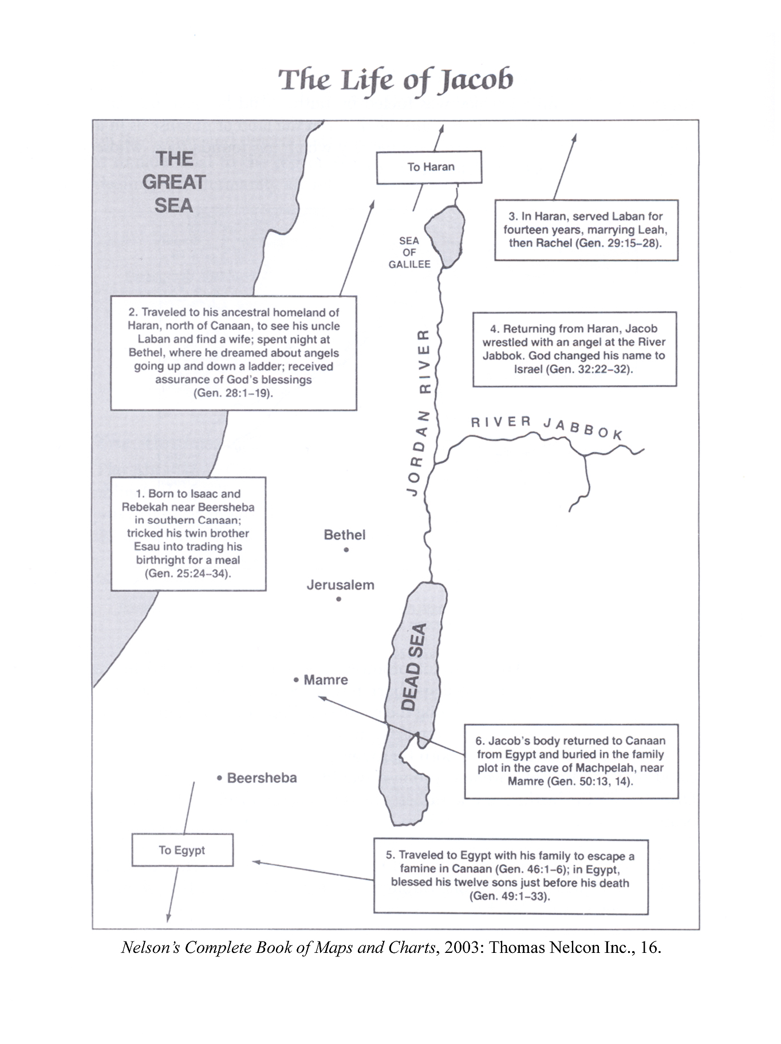

Levirate Marriage
Deuteronomy 25:7 instructs that when a man died without a son, one of his near kinsmen, usually a brother, was to marry the deceased man’s wife in order to “raise up unto his [dead] brother a name in Israel” (see Deut 25:5–10). The first son born in this union was considered the “legal” son of the dead man, in terms of inheritance. This practice is called “levirate marriage” (from Latin, levir, “husband’s brother”).
In antiquity, without life insurance, social security, and other modern types of social and economic safety nets, a widow without living children was vulnerable to hardship, poverty, and even starvation, because as a woman she could not own property (Numbers 27:1-11 and 36:6-9 provides an exception if there was no male heir). In order to assist women in such circumstances, levirate marriages provided economic stability and social respectability through marriage and having children. Additionally, the practice also provided a means by which a “son” of the deceased could inherit the dead man’s property, insuring that family land (a powerful symbol and significant economic matter) remained in the family to provide aged parents with economic security. So important was this levirate responsibility that when the brother of the deceased did not fulfill his responsibility, the widow could accuse him in front of the “elders” by three separate actions—taking off the man’s sandal, spitting in his face, and testifying against him—actions that certainly humiliated him in a community where honor and shame were important social constructs (see Deut 25:7–10).
In addition to the Deuteronomic regulations just mentioned, the levirate principle underlies the accounts of Tamar (Gen 38) and Ruth (Ruth 3-4). However, the particulars in both of these cases go beyond the basic levirate provision in Deuteronomy 25, and the account in Genesis 38 reflects pre-Mosaic [and thus, pre-Deuteronomic] practice.
Holzapfel, Pike, and Seely, Jehovah and the World of the Old Testament (2009), 189.

